Name each polygon and find the sum of the interior and exterior angles.

1) 2) 3)

Int angle sum: Ext angle sum: Int angle sum: Ext angle sum: Int angle sum: Ext angle sum:

4) Find the measure of ONE EXTERIOR angle of a regular octagon.

5) Find the measure of ONE INTERIOR angle of a regular 20-gon.

6) The measure of ONE INTERIOR angle of a regular polygon is 150 degrees. How many sides does it have?

Use the diagram of parallelogram VWXY at the right. Complete each statement and give a reason for your answer.

V W

Y X

T

7)  9) 

10)  11) 

12)  13) ||

14)  is supplementary to _________ and _________.

15) Point T is the midpoint of ________ and ________.

16) Find x

3*x*°

4*x*°

(2*x* +18)°

(4*x* - 17)°

(2*x* + 14)°

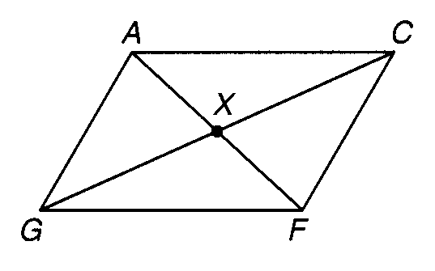17-20 Use **parallelogram** ACFG

17) If *AG* = 3*x* + 10 and *CF* = 5*x* - 4

*x* = ____________, *CF* = ____________

18) If *GX* = 2*x* + 2 and *XC* = 6*x* - 6, find *GC*.

*x* = ____________, *GC* = ____________

19) If m<*GAC* = 2*x* + 3 and m<*ACF* = 4*x* + 15, find m<*AGF*.

*x* = ____________,  = ____________

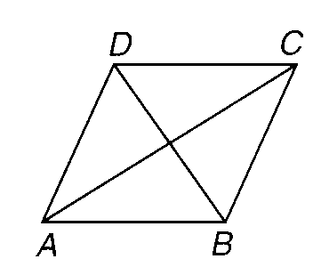20-21 Use **rhombus** ABCD

20) If m<*ABD* = 2*x* + 10 and m<*DBC* = 4*x* - 20, find m<*ABC*.

*x* = ____________, m<*ABC* = ____________

21) If *BC* = 5*x* + 24 and *CD* = 7*x*, find *x*.

*x* = ____________, *AD* = ____________

22-25 Use **rectangle** RSTU

22) ]If *RT* = 4*x* - 40 and *SU* = 30 - *x*, find *SU*.

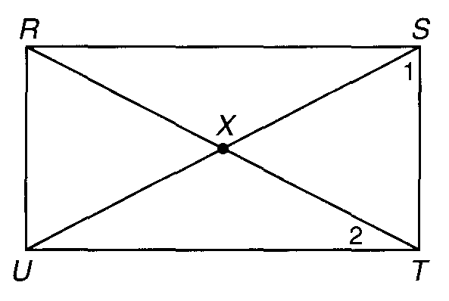*x* = ____________, *SU* = ____________

23) If *SX* = 2*y* + 2*x*, *XU* = 6*y* - 10, and *RX* = 32 find the values of *x* and *y*.

*x* = ____________, *y* = ____________

24) If m<*SRT* = 4*x* - 4 and m<*TRU* = 5*x* - 14, find m<*TRU*.

*x* = ____________, m<*TRU* = ____________

25) If m<*SRT* = 35 find m<*RXU*.

m<*RXU* = ____________

26) Draw a Venn diagram (or tree diagram) showing the relationship between ***parallelograms, squares, rectangles, rhombuses, trapezoids, isosceles trapezoids, kites, and quadrilaterals***.

For 27-47 Determine if the statement is always, sometimes, or never true.

1. A rectangle is a square. ____________
2. A rhombus is a square. ____________
3. The adjacent angles of a rhombus are supplementary. ____________
4. A quadrilateral is a parallelogram if one pair of opposite sides is both congruent and parallel. ____________
5. The adjacent angles of a rectangle are congruent and supplementary. ________
6. The diagonals of a parallelogram are congruent. ____________
7. If the diagonals of a parallelogram are both perpendicular and congruent, then the quadrilateral is a square. ____________
8. The diagonals of a parallelogram bisect both pairs of opposite angles. __________
9. A square is a parallelogram, a rhombus, and a rectangle. ____________
10. A diagonal of a square bisects opposite angles. ________________
11. All angles of a parallelogram are congruent. ________________
12. The diagonals of a parallelogram are perpendicular. ________________
13. The diagonals of a rectangle are perpendicular. ________________
14. Consecutive sides of a rhombus are congruent. ________________
15. Opposite sides of a rectangle are congruent. ________________
16. Opposite angles of a rhombus are supplementary and congruent. ________________
17. Diagonals of a square are congruent. ________________
18. Diagonals of a trapezoid are congruent______________
19. Diagonals of a kite are perpendicular ___________________
20. The legs of a trapezoid are congruent____________________
21. The angles of a kite add up to 360 degres___________________

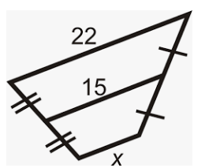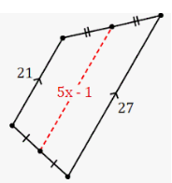Solve for x in the following trapezoids.

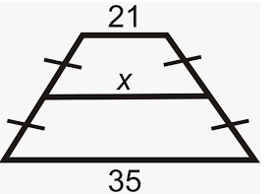  
48) 49) 50)

X = _____________ x = ________­­­­_______ x = __________________

Solve for all missing angles in the trapezoids.

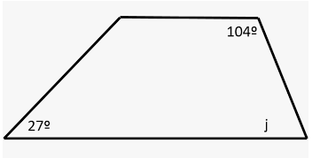51) 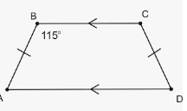 52)

A=_____ B=______ C=______ D = ______ J = ________

Solve for the missing lengths or angles in the following kites.

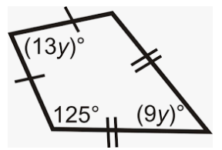53) 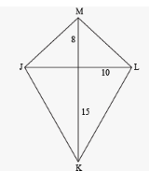 54)

ML = ______ LK = ______ y = ___________